Tool and Machine Identification Name: ______________________________
Grade 6 Technology Period: _________
Directions: Match the tool or machine name to its picture or description to the right. Write the letter of the answer on the line.

1. _________ Phillips Head Screwdriver A. A tool normally used for the application of flame or heat which uses propane, a hydrocarbon gas for its fuel.

2. _________ Flathead/Slotted Screwdriver B. 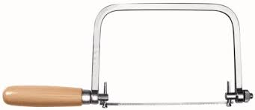

3. _________ Scratch Awl C. A wood-boring bit shaped like an auger but without a handle, one end of which usually has a square tang to fit the chuck of a brace.

4. _________ Band Saw D.

5. _________ Random Orbit Sander E. A tool used to either tighten or loosen slotted screws with a single indentation in the head.
6. _________ Hacksaw
F. 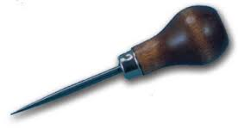

7. _________ Wood Chisel G. A saw with a continuous band of toothed
metal stretched between two or more wheels
to cut material.

H. 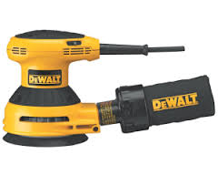

8. _________ Drill Press I. Used for rough boring in wood. They tend to cause splintering when they emerge from the workpiece. Avoid splintering by finishing the hole from the opposite side of the work.

9. _________ Spade Bit J. 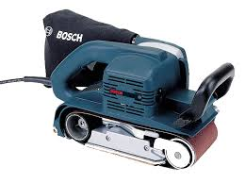

10. ________ Portable Belt Sander K. A powered vertical drilling machine in
which the drill is pressed to the work
automatically or by a hand lever.

11. ________ Planer L. 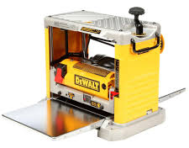

12. ________ Auger Bit M. Small electric saw used to cut intricate curves in wood, metal, or other materials.

13. ________ Air Compressor N. 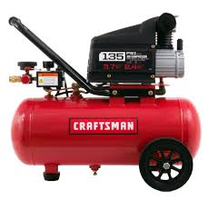

14. ________ Scroll Saw O. A fusible metal alloy used to create a permanent bond between metal work pieces.

15. ________ Coping Saw P. 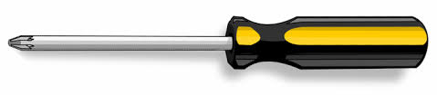

16. ________ Twist or Spiral Bit Q. A fine-toothed saw, originally and principally made for cutting metal. It can also be used for cutting plastic.

17. ________ Solder R. 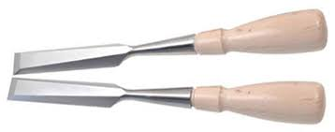

18. ________ Soldering Iron/Gun S. It supplies heat to melt solder so that it can flow into the joint between two work pieces.

19. ________ Propane Torch

Directions: Match the tool or machine name to its picture or description to the right. Write the letter of the answer on the line. Any answer letter can be used for any of the tools/machines/materials.

1. _________ Soldering Paste/Flux A. Used to cut various pieces of sheet metal. Can cut straight and curved.

2. _________ Channellock Pliers B.

3. _________ Crescent Wrench C.Applied to surfaces that are to be joined by soldering; flux cleans the surfaces and results in a better bond between the metal.

4. _________ Claw Hammer D. 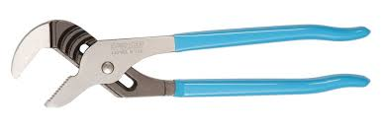

5. _________ C-Clamp E. An adjustable spanner designed to grip hexagonal nuts/bolts, with an adjusting screw fitted in the crescent-shaped head of the spanner.
6. _________ Pipe Wrench F. 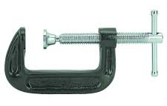.

7. _________ Metal Brake G. Used to bend various types of sheet metal

8. _________ Metal Shear I. 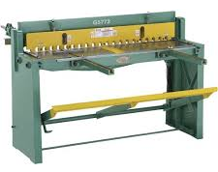

9. _________ Combination Wrench J. Pound in nails and the “prongs” are used to remove nails. Hold this tool at the end of the handle to increase leverage/power.

10. ________ Tin Snips K.

Directions: Match the tool or machine name to its picture or description to the right. Write the letter of the answer on the line. Any answer letter can be used for any of the tools/machines/materials.

1. _________ Sandpaper A. Used to clean metal that may contain rust, dirt, etc. prior to painting

2. _________ Bench Vise B. 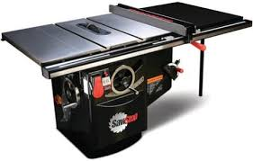

3. _________ Steel Wool C. Creates straight and angled cuts in wood

4. _________ Miter Saw D. 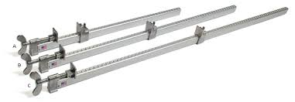

5. _________ Bar Clamp E. Used to remove material in wood and/or to create decorative edges on a piece of wood, such as a chamfer.

6. _________ Table Saw F. 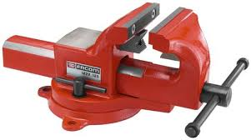

7. _________ Router G. Used to smooth wood and other materials such as plastic.

8. _________ Radial Arm Saw H. 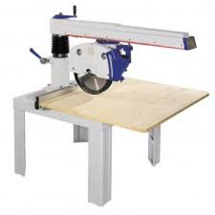

9. _________ Rubber Mallet I. Used to assemble things when you do not want to ruin the work piece.

Directions: Match the tool or machine name to its picture or description to the right. Write the letter of the answer on the line. Any answer letter can be used for any of the tools/machines/materials.

1. _________ Biscuit Joiner A. Used to create a flat-bottom recessed hole in wood.

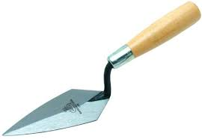
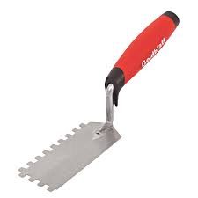
2. _________ Masonry Trowel B. 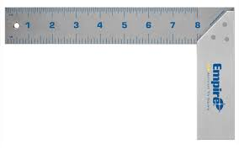

3. _________ Try-Square C. Used to join two edges of wood together. It creates a crescent shaped hole in the wood edges and a wood “football” is used to hold them together using glue.

4. _________ Forstner Bit D. 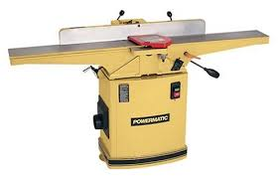

5. _________ Level E. Used to make sure things are straight (horizontal-180*) and plumb (vertical-90*)

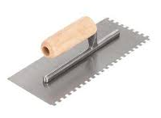

6. _________ Metal File F.

7. _________ Bench Grinder G. A wheel used to sharpen metal (chisels). You can also put buffing and wire wheels on them.

8. _________ Joiner H. 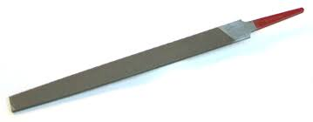

9. _________ Hand Plane I. A manual method of planing down an edge of a piece of wood. For example: planning the edge of a door so it closes better.

10. ________ Mortising Machine J. 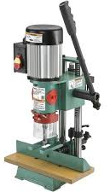

Directions: Match the tool or machine name to its picture or description to the right. Write the letter of the answer on the line. Any answer letter can be used for any of the tools/machines/materials.

1. _________ Grout Float A. Used to cut various materials including cardboard.

2. _________ Voltage Tester B. 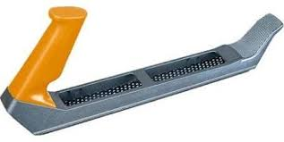

3. _________ Wire Strippers C. Insert and remove screws, drill holes, insert and remove nuts and bolts, etc.

4. _________ Diagonal Cutters D. 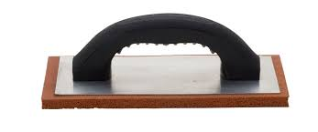

5. _________ Utility Knife E. Checks to see if there is any power in a wire, such as an electrical outlet or switch.

6. _________ Wood Rasp F. 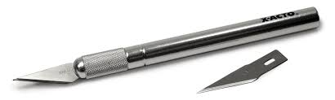
7. _________ Cordless Drill/Impact Driver G. Used to cut wires

8. _________ X-Acto Knife H.

9. _________ Backsaw I. 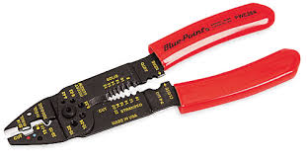

Directions: Match the tool or machine name to its picture or description to the right. Write the letter of the answer on the line. Any answer letter can be used for any of the tools/machines/materials.

1. _________ Needle Nose Pliers A. A machine in which the cutters rotate
to remove the material from the work
piece present in the direction of the
angle with the tool axis.

2. _________ Tape Measure B. 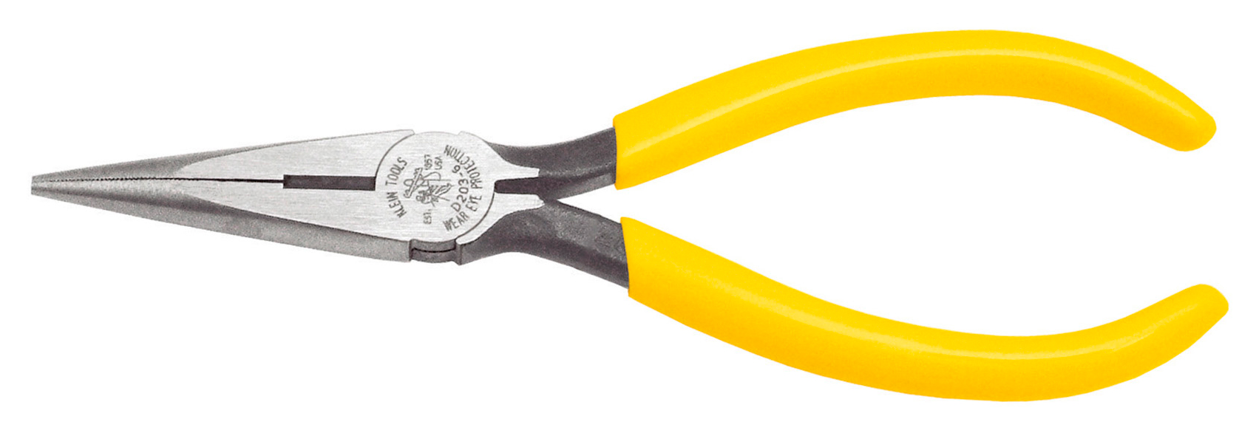

3. _________ Brace C. Used to turn a piece of wood into a round object, such as a baseball bat or table leg.

4. _________ Socket Set D. 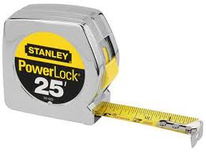

5. _________ Car Jack and Jack Stands E. Sander that spins and moves up and down used to sand inside curves in wood

6. _________ Tire Iron F. 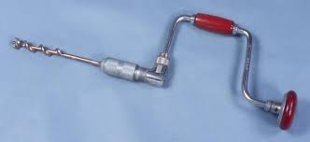

7. _________ Oscillating Spindle Sander G. Used to loosen/tighten various sized lug nuts from a vehicle’s wheel

8. _________ Wood Lathe H. 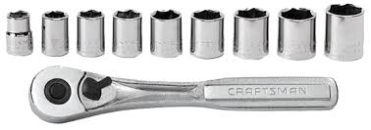

9. _________ End Mill I. 